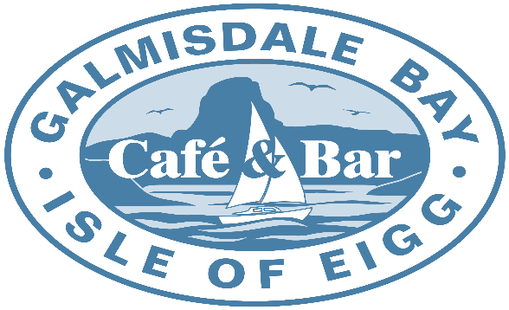

Pizza Menu

Our Pizza Menu is served between
6pm – 8pm
We sell
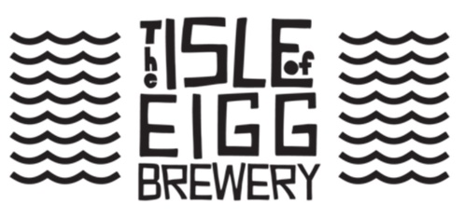
Beer on Draught
Pizzas
All our Pizzas are hand made to order, so you can’t get fresher.
Pizzas
2 Cheese Margherita with Mozzarella and Mature Cheddar |  |  |  | £13.00
Pepperoni, Salami and Mozzarella |  |  |  | £13.50
Pancetta, Mushroom, Mascapone and Mozzarella on on a White Sauce on Base |  |  |  | £13.50
Sun dried Tomato, Garlic, Spinach, Feta and Mozzarella |  |  |  | £13.50
Cajun Chicken, Pesto, Tomato and Mozzarella |  |  |  | £14.50
Haggis, Stornoway Black Pudding, Brie and Mozzarella |  |  |  | £14.00
Mixed Peppers, Red Onion, Spinach and Mozzarella with Garlic and Herb Sauce |  |  |  | £13.50
Spicy Beef, Red Onion, Jalepenos and Mozzarella with a BBQ Sauce on base |  |  |  | £14.50
Scallops, Mussels, King Prawns and Mozzarella on a White Sauce base with Parsley and Basil oil |  |  |  | £16.50
Garlic Bread Pizza |  |  |  | £12.00
Garlic Bread Pizza with Mozzarella |  |  |  | £13.00
Salads |  | Dips
Dressed Leaf Salad | £4.50 | Garlic and Herb | £1.50
Coleslaw | £4.95 | Sriracha | £1.50
Vegan Coleslaw | £4.95 | Arran Mustard | £1.50

Regular Mozzarella can be substituted for Vegan Mozzarella where required and vice versa. GF bases available when preordered.

