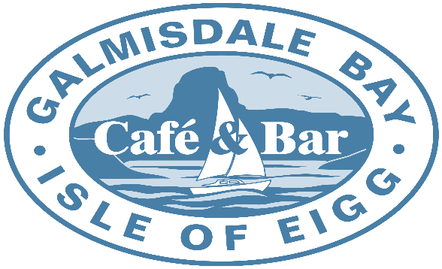

Evening Menu

Our Evening Menu is served between
6 – 8.00pm
We sell
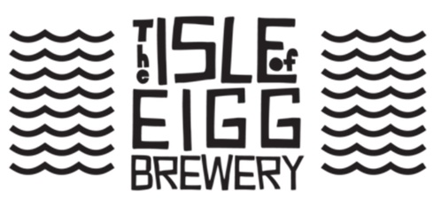
Beer on Draught

Small Plates
Soup of the Day
Served with Fresh House Baked Bread and Butter (GF Bread Available) |  |  |  |  |  |  | £7.95
Letterfinlay Naturally Smoked Haddock House Fishcake
With a Dressed Fresh Garden Salad and Sweet Chilli Drizzle GF |  |  |  |  |  |  | £9.50
Calamari
Freshly prepared Squid with a Sriracha Mayo Dip and Lemon GF |  |  |  |  |  |  | £9.50
Cullen Skink
Classic Scottish Soup made of Letterfinaly Naturally Smoked Haddock and Potatoes, with Fresh House |  |  |  |  |  |  | £11.50
Baked Bread and Butter (GF Bread Available)
Large Plates
Fish & Chips
Eigg Pale Ale Beer Battered Haddock served with Double Cooked Hand Cut Chips, |  |  |  |  |  |  | £19.50
Served with either Side Salad & Red Slaw or Garden Peas and House Tartare Sauce
Scampi & Chips
Wholetail Breaded Scampi served with Double Cooked Hand Cut Chips GF |  |  |  |  |  |  | £18.50
Served with either Side Salad & Red Slaw or Garden Peas and House Tartare Sauce
Mixed Seafood Tagliatelle
Mussels, King Prawns and Scallops in a rich Lemon, Chilli, Garlic and Tomato sauce GF |  |  |  |  |  |  | £19.50
Finished off with Parmesan Shavings
Haggis Lasagne layered with a Whisky & Leek Sauce (Veg/Vegan Option)
With a Rich Tomato Sugo, House Dressed Salad and Fresh House Baked Garlic Bread |  |  |  |  |  |  | £18.50
Letterfinlay Smoked Cheddar Macaroni
Served with House Coleslaw and either Chips or Garlic Bread |  |  |  |  |  |  | £17.50
Haggis/Veggie Haggis or Black Pudding |  |  |  |  |  |  | £1.75
Arisaig Mussels
Steamed in a White Wine, Garlic, Parsley and Cream Sauce served with GF |  |  |  |  |  |  | £19.00
Fresh House Baked Bread
Burgers
Why not try one of our House Made Burgers
- 8oz Beef Burger with a Mustard Mayo Dressing GF
- Succulent Whole Chicken Breast marinated in Garlic Oil and Cajun Spice with a Spicy Sriracha Mayo Dressing GF
- ‘Meety’ Roast Veg and Bean, Veggie/Vegan Burger with a Garlic Mayo Dressing GF
All Served on a Fresh House Baked Roll, Garnished with Crunchy Lettuce, Tomato and Sliced Red Onion
with a side of Double Cooked Hand Cut Chips and House Coleslaw or Vegan Coleslaw |  |  |  |  |  | £17.50
Why Not Add
Stornoway Black Pudding, Haggis, Veg/Vegan Haggis, or Bacon |  |  |  |  |  | £1.75 ea.
Brie, Cheddar Cheese, Vegan Cheese, Letterfinlay Smoked Cheddar |  |  |  |  |  | £1.75 ea.
Desserts
Chocolate Brownie
Hot Chocolate Brownie served with Fudge Arran Ice Cream and Chocolate Sauce |  |  |  |  |  | £7.50
Sticky Toffee Cheesecake
With a Shortbead base and Toffee Sauce |  |  |  |  |  | £7.50
Kids Menu
Fish and Chips |  | £7.75 |  | Scampi and Chips |  | £7.75
Beef Burger and Chips |  | £7.75 |  | Veggie/Vegan Burger and Chips |  | £7.75
Sausage and Chips (Veggie/Vegan option) |  | £7.75
All served with either Heinz Beans or Garden Peas
Sides |  |  |  |  | House made Dips
Double Cooked Hand Cut Chips | £3.25 |  |  |  | Garlic and Herb Mayo | £1.00
Purple Slaw | £4.50 |  |  |  | Arran Mustard Mayo | £1.00
Vegan Purple Slaw | £4.50 |  |  |  | Sriracha Mayo | £1.00
Garden mixed Salad | £4.00
Garlic Bread | £3.25

