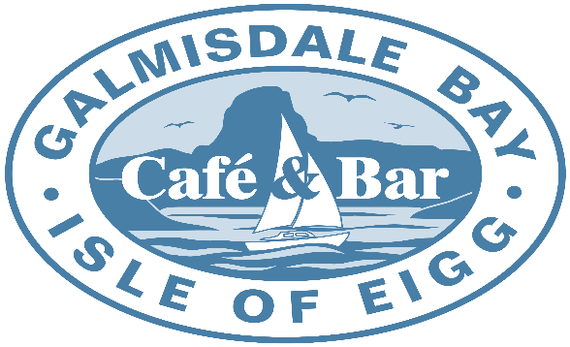

Pizza Menu

Our Pizza Menu is served between
6 – 7.30nhpm
We sell
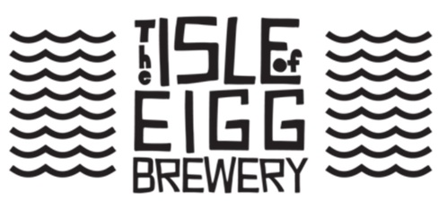
Beer on Draught
Pizza Friday

All our Pizzas are hand made to order, so you can’t get fresher.

Pizzas
2 Cheese Margherita with Mozzarella and Mature Cheddar |  |  |  | £13.00
Pepperoni, Salami and Mozzarella |  |  |  | £13.50
Pancetta, Mushroom, Mascapone and Mozzarella |  |  |  | £13.50
Sun dried Tomato, Garlic, Spinach, Feta and Mozzarella |  |  |  | £13.50
Cajun Chicken, Pesto, Tomato and Mozzarella |  |  |  | £14.50
Haggis, Stornoway Black Pudding, Brie and Mozzarella |  |  |  | £14.00
Vegan Haggis, Onion, Rocket Vegan Mozzarella |  |  |  | £13.50
Garlic Bread Pizza |  |  |  | £11.00
Garlic Bread Pizza with Mozzarella |  |  |  | £13.00
Salads
Dressed Leaf Salad | £4.50 | Coleslaw | £4.95
 |  | Vegan Colslaw | £4.95

Regular Mozzarella can be substituted for Vegan Mozzarella where required and vice versa.

